CS-555 Assignment 4: Written Section

Name: Ved Ranade

Answer 1:

Proof for A ⊕ B = B ⊕ A:

The definition of dilation is: A ⊕ B = {Z | (B^)2 ∩ A ≠ ∅ }

On translation, the following definition is obtained: {Z | ^B ∩ (A)-z ≠ ∅ }

On reflection, the following definition is obtained: {Z | B ∩ (^A)z ≠ ∅}

Answer 2 (a):

Performing the opening operation on the original image using the structuring element provided produces the following result:

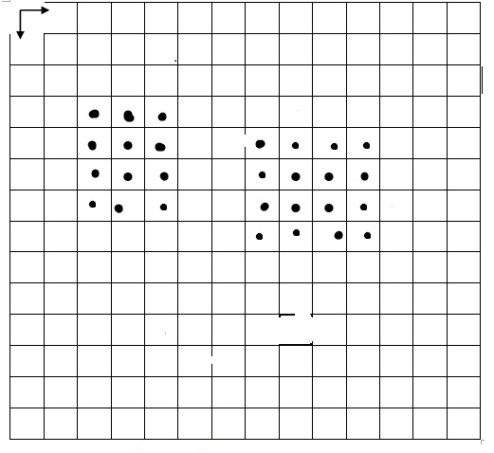

Answer 2 (b):

Performing the opening operation on the original image using the structuring element provided produces the following result:

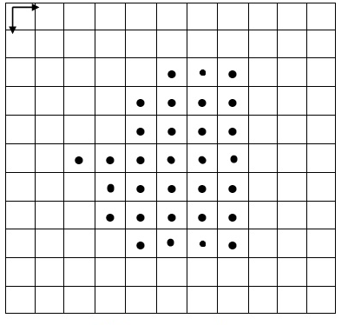

Answer 3 (a):

Structure of given PDL:

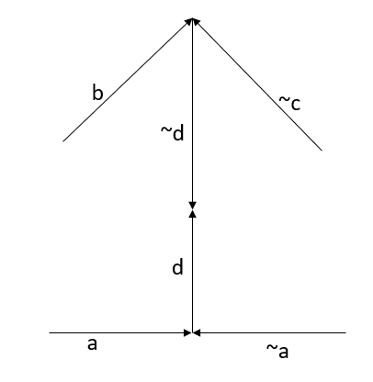

Answer 3 (b):

PDL of the first given structure:

[[a – (~a)] + d] + [e \* f]

PDL of the second given structure:

[e \* f] + [e \* f]